State of Nevada  Nevada Health Authority  Division of Consumer Health Services Silver State Health Insurance Exchange  Carson City, NV 89701 | 




NEVADA HEALTH AUTHORITY DIVISION OF CONSUMER HEALTH SERVICES SILVER STATE HEALTH INSURANCE EXCHANGE

Plan Certification Guide
February 12, 2026
Version 6

February 12, 2026 V6.0 Plan Certification Guide Page 1 of 20

Table of Contents
- Introduction 3
- Initial Submission and Plan Preview 6
  - Initial Submission and Binder Review 6
  - Objections 6
  - Data Transfer 6
  - Certification/Verification 7
- Data Change Request 9
  - Request for State Authorization 9
  - Revision and Resubmission 9
  - Objections 10
  - Data Transfer 10
  - Certification/Verification 10
- Final Plan Certification 11
  - DOI Compliance 11
  - Issuer Agreements and Final Plan Listings 12
  - Plan Certification 12
- Plan Withdrawal 13
  - Withdrawal Request 13
  - Plan Withdrawal Confirmation 14
- Plan Decertification 15
  - Non-Compliance Determination 16
  - Notice of Decertification 17
  - Appeals Process 17
  - Decertification Process 17
- Appendix A: Plan Certification Statuses 18
- Terms and Definitions 19
Document Revision History 20

Introduction
The NEVADA HEALTH AUTHROITY, DIVISION OF CONSUMER HEALTH SERVICES, SILVER STATE HEALTH
INSURANCE EXCHANGE (SSHIX) Plan Certification Guide provides a detailed overview of the annual Plan Certification process for the Nevada Health Link State Based Exchange (SBE) Platform, defining the coordinated roles and responsibilities of SSHIX, the Nevada Division of Insurance (DOI) and Nevada’s On- Exchange Insurance Carriers (Issuers). Each year these organizations must work collaboratively to ensure that Qualified Health and Dental Plans available for purchase through Nevada Health Link meet all applicable state and federal requirements, and that all plan data displayed to Nevada Health Link’s consumers accurately reflects the Issuers’ intended plan designs.

Document Structure
This document divides the Plan Certification process into four distinct sections, each of which is applicable for a limited portion of the overall Plan Certification timeline. The exact dates for each portion of the timeline will vary from year to year, so please consult SSHIX ’s annual Letter to Issuers for specific yearly dates. The current Letter to Issuers can be downloaded from Nevada Health Link’s Carrier Resources page at https://www.nevadahealthlink.com/partner-resources/carriers/.

Plan Certification Timeline
The Letter to Issuers that is released from SSHIX outlines the Plan Certification Timeline. Please refer to this document for more details.

Flow Charts
Each section begins with a flow chart illustrating the steps required to complete that portion of the Plan Certification process. The horizontal rows of the flow charts depict the various entities participating in the Plan Certification process: Issuers are represented in the top row, SSHIX in the middle row, and DOI in the bottom row. Each flow begins with the topmost box on the far left and flows in the direction of the arrows connecting each box. The boxes are color-coded into groups of related functions, and each group is described in detail in the appropriate section of this guide.
PLEASE NOTE: The flow charts do not necessarily represent a linear sequence of events. Certain processes, such as the Initial Binder Reviews conducted by SSHIX and DOI, occur in parallel. In addition, certain processes can be circular, such as when objections are identified, and a plan needs to be revised and resubmitted.
In addition to the horizontal rows the flow charts are divided vertically into left and right sections, which represent the two information systems utilized during the Plan Certification process. The left section, illustrated under a gray-colored banner, represents actions related to SERFF. The right section, illustrated under a maroon-colored banner, represents actions related to the SBE Platform.

Plan Statuses within the SBE Platform
The flow charts in this guide reference a number of different statuses, which represent the various stages of the Plan Certification process. These statuses are described in detail in Appendix A: Plan Certification Statuses.

Issuer Representatives
This document uses the term “Issuer Representative” in reference to the specific user role in the SBE Platform which is associated with the Verification/Plan Preview functions. This term is used
interchangeably with “Issuer” to refer collectively to the Issuer personnel who are responsible for Plan
Certification.
A complete listing of all SBE Platform functions available to the Issuer Representative role is documented in the Nevada Health Link Issuer Representative User Reference Manual. To request a copy of this manual please contact the SSHIX Plan Certification Manager at pmanagement@nvha.nv.gov.

System for Electronic Records and Form Filings (SERFF)
Detailed instructions for utilizing the SERFF platform are out-of-scope for this document. For more information on SERFF, including instructions for gaining access to the system, please visit the SERFF “Getting Started” page or contact the SERFF Help Desk.

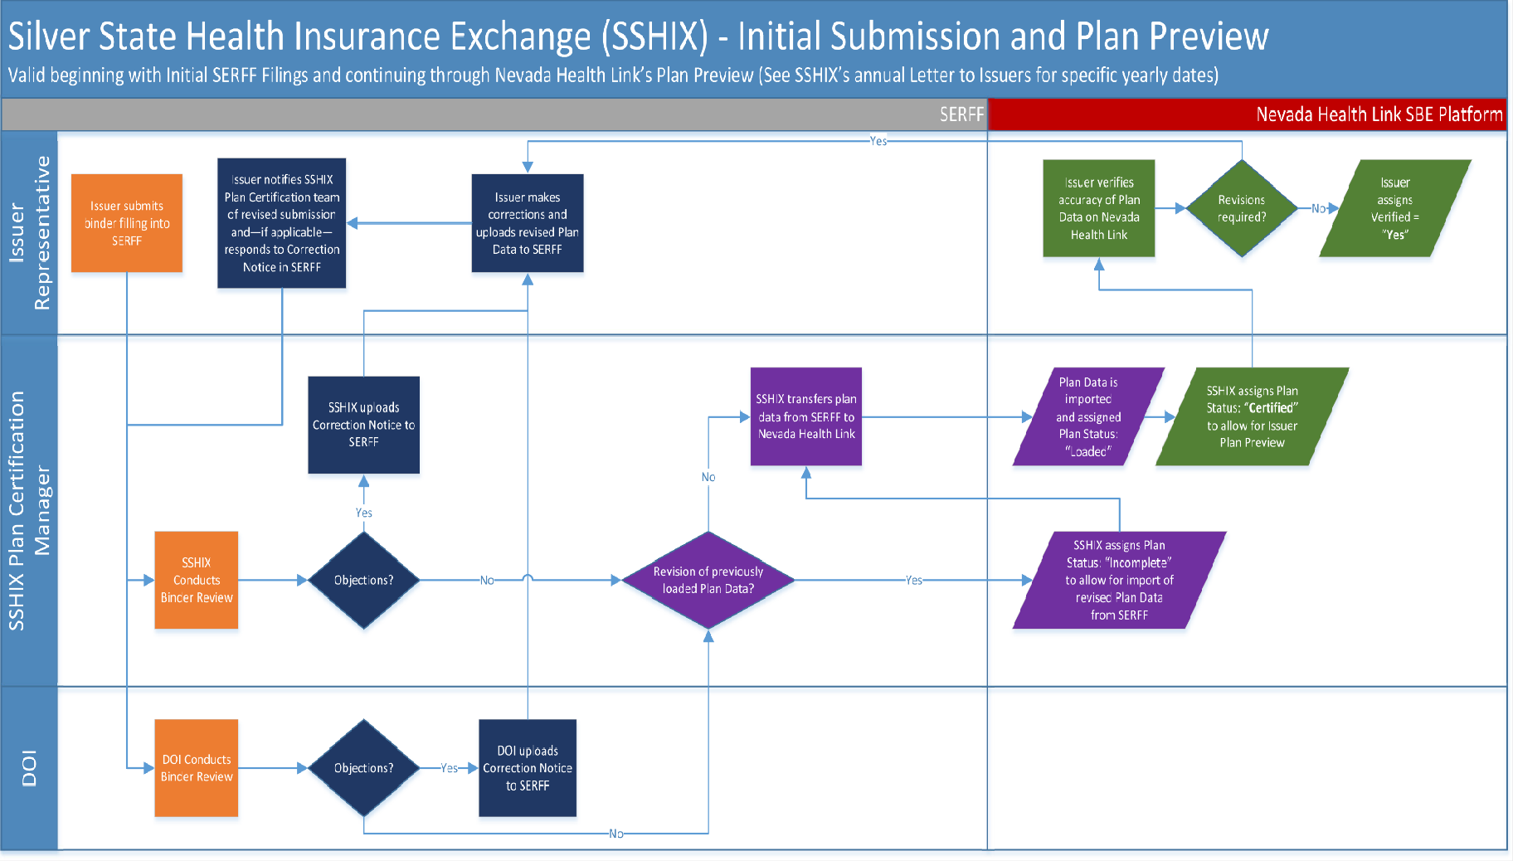
Figure 1: Initial Submission and Plan Preview

Initial Submission and Plan Preview
Figure 1 on the previous page illustrates the Initial Submission and Plan Preview portion of the Plan Certification process, which applies to the time period between the initial binder submission deadline and the close of Plan Preview. For specific yearly dates please refer to SSHIX ’s annual Letter to Issuers, which can be downloaded from Nevada Health Link’s Carrier Resources page.

Initial Submission and Binder Review
The annual Plan Certification process begins with the initial submission of QHP/QDP binder data to SERFF. For detailed guidance regarding SERFF submissions please visit Nevada Health Link’s Carrier Resources page.

Following initial binder submission SSHIX and DOI begin their respective Binder Review processes. and DOI conduct binder review simultaneously, but the agencies verify different aspects of compliance. DOI is primarily responsible for verification of rates, form filings, and network adequacy, and SSHIX is primarily responsible for verification of health benefits.

Objections
After and DOI have completed their Binder Reviews they will notify carriers if any objections are identified. PLEASE NOTE: Objections can be filed at any time until the close of Plan Preview.

No Objections present
If no objections are identified by SSHIX or DOI then the flow proceeds to Section 2.3 - Data Transfer.

Objections present
If SSHIX and/or DOI identify any objections during their respective Binder Reviews, then the objections are documented in a Correction Notice and uploaded to SERFF. The Issuer Representative then makes the required corrections and uploads the revised plan data to SERFF. Following the upload of revised plan data, the Issuer Representative notifies the SSHIX Plan Certification team of their revised submission (pmanagement@nvha.nv.gov) and, if applicable, responds to the Correction Notice in SERFF. This process continues until the binder reviews are completed with no objections identified.

Data Transfer
After any objections have been resolved the SSHIX Plan Certification Manager will transfer (or
“push”) the plan data from SERFF to the Nevada Health Link SBE Platform.
Before executing the transfer SSHIX will verify whether the plan data in question represents a revision of a previously loaded plan. If so, then the plan’s status must be updated to

“Incomplete” in order to allow the SBE Platform to overwrite the previous version of the plan
(Please see Appendix A: Plan Certification Statuses for more details).
When the plan data is transferred from SERFF it is imported to the SBE Platform with a
default status of “Loaded.” Plans in “Loaded” status are only visible to the Plan Certification
Manager.

Certification/Verification
After verifying the accuracy of the transferred data the SSHIX Plan Certification Manager will update the plan’s status to “Certified,” making the plan data available to Issuer Representatives in the Plan Preview module. Plan Preview is available for a limited time period each year. For specific yearly dates please refer to SSHIX ’s annual Letter to Issuers, available for download from the Nevada Health Link Carrier Resources page.
Once the plan data is available in Plan Preview the Issuer Representative verifies the accuracy
of the data using the SBE Platform’s plan comparison tools and graphical user interface. Detailed instructions for utilizing the Plan Preview feature are contained in Section 4.9 of the Nevada Health Link Issuer Representative User Reference Manual. If the plan data is accurate and no revisions are required, then the Issuer Representative Verifies the plan data using the process described in Section 5.3 of the Nevada Health Link Issuer Representative User Reference Manual.
If inaccuracies are identified during Plan Preview then the Issuer Representative must make the appropriate revisions, upload the revised plan data to SERFF, and notify the SSHIX Plan Certification team of the revised submission by email at pmanagement@nvha.nv.gov
PLEASE NOTE: The Nevada Health Link Issuer Representative User Reference Manual is provided to Issuer Representatives at the time of their initial SBE Platform user account creations. However, due to the proprietary nature of its content the manual is not available for download from the Nevada Health Link website. To obtain a copy of the manual please contact the SSHIX Plan Certification Manager at pmanagement@nvha.nv.gov.

August 2025, V5.0 Plan Certification Guide Page 7 of 20

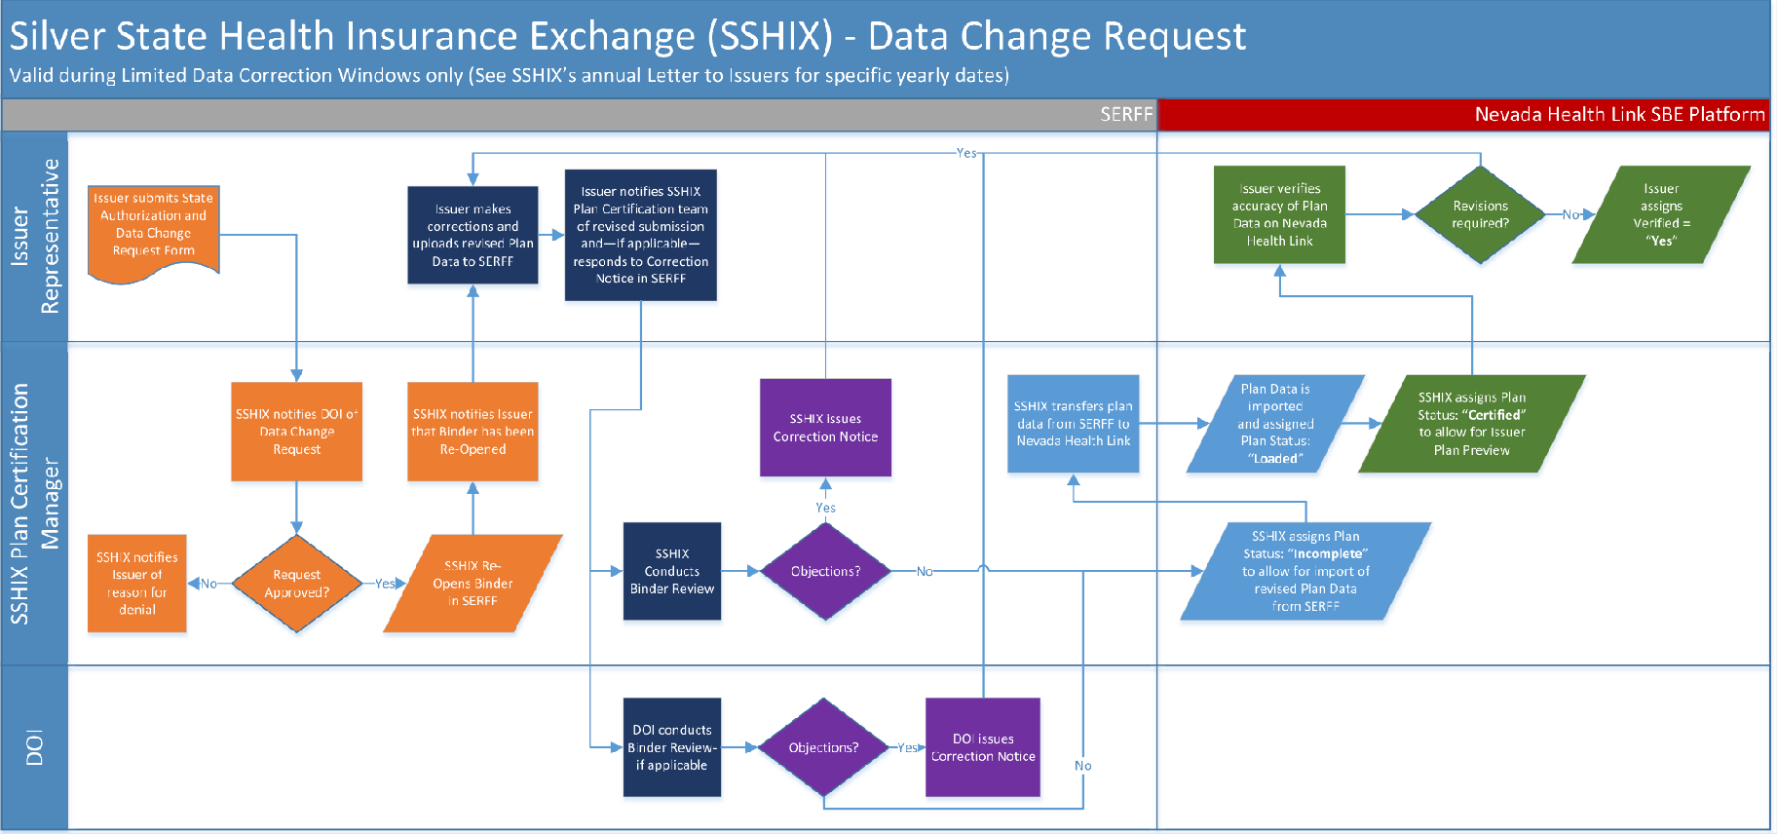
Figure 2 – Data Change Request

Data Change Request
Figure 2 on page 9 illustrates any Data Change Request portion of the Plan Certification process, which applies only during Limited Data Correction Windows prior to plans being certified¹.

Request for State Authorization
The Issuer Representative initiates any Data Change Request to include changes to the DOI process must submit a State Authorization and Data Change Request Form to the SSHIX Plan Certification Manger (pmanagement@nvha.nv.gov). This form is available for download from Nevada Health Link’s Carrier Resources page.
Upon receipt SSHIX will notify DOI of the request, and SSHIX and DOI will review the request for approval.

Data change request approved
If the Data Change Request is approved, then the SSHIX Plan Certification Manager will re- open the binder in SERFF and notify the Issuer that the binder is available for revision.

Data change request denied
If the Data Change Request is not approved, then the SSHIX Plan Certification Manager will notify the Issuer of the reason for denial.
*Caution: Should an issuer representative fail to notify SSHIX of any data change, within the limited data correction window. Any corrections needed, may be subject to additional systematic fees at the expense of the Issuer.

Revision and Resubmission
Following approval of the Data Change Request the Issuer Representative makes the necessary revisions and manually uploads the revised plan data. Next, the Issuer Representative notifies the SSHIX Plan Certification team of their revised submission (pmanagement@nvha.nv.gov).
Upon receipt of this notification SSHIX and DOI will begin their respective binder review processes. SSHIX and DOI conduct binder review simultaneously, but the agencies verify different aspects of compliance. DOI is primarily responsible for verification of rates, form filings, and network adequacy, and SSHIX is primarily responsible for verification of Essential Health Benefit coverage under the Affordable Care Act.

¹ For specific yearly updates please refer to SSHIX ’s annual Letter to Issuers, which can be downloaded from
Nevada Health Link’s Carrier Resources page.

Objections
For a detailed description of the Data Objections process please refer to Section 2.2 –
Objections.

Data Transfer
For a detailed description of the Data Transfer process please refer to Section 2.3 – Data Transfer.

Certification/Verification
For a detailed description of the Certification/Verification process please refer to Section 2.4
– Certification/Verification.

Final Plan Certification
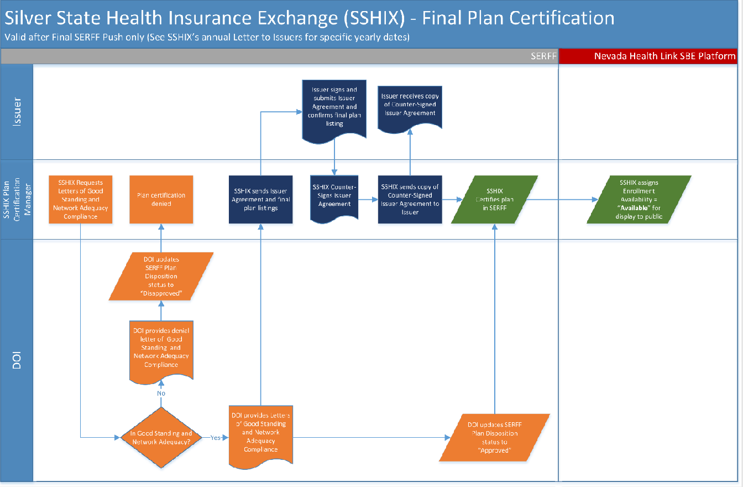
Figure 3 – Final Plan Certification
Figure 3 illustrates the Final Plan Certification portion of the annual Plan Certification Process, which applies to the time period between the Limited Data Correction Window and the annual deadline for Final Plan Certification. For specific yearly dates please refer to SSHIX ’s annual Letter to Issuers, which can be downloaded from Nevada Health Link’s Carrier Resources page.

DOI Compliance
SSHIX initiates the Final Plan Certification process by requesting Letters of Good Standing and Network Adequacy Compliance from DOI. SSHIX notifies DOI that the Issuer has completed the plan verification process. DOI’s response to this request determines whether or not a plan can be displayed to consumers during Window Shopping and made available for enrollment during the Open Enrollment Period.

Issuer is in good standing and network is adequate
If the Issuer is in good standing and the network adequacy is compliant then DOI provides Letters of Good Standing and Network Adequacy Compliance to SSHIX, and DOI updates the Plan Disposition Status to “Approved” in SERFF. The Final Plan Certification process then proceeds to Section 4.2 – Issuer Agreements and Final Plan Listings.

Issuer is not in good standing and/or network is inadequate
If the Issuer is not in good standing and/or the network adequacy is not compliant, then DOI provides a Denial Letter to SSHIX and updates the Plan Disposition Status to “Disapproved” in SERFF. Plans which do not receive DOI approval cannot be made available to Nevada Health Link consumers.

Issuer Agreements and Final Plan Listings
Following confirmation of DOI Compliance, SSHIX sends the Issuer Agreement and final plan listings to the Issuer via email. The Issuer then signs the Issuer Agreement, confirms the final plan listings, and sends signed Agreement back to SSHIX via email to pmanagement@nvha.nv.gov.
When the signed Issuer Agreement is received, SSHIX will counter-sign the Agreement and send a copy of the counter-signed Agreement back to the Issuer via email.

Plan Certification
After both parties sign the Issuer Agreement (SSHIX and Issuer), SSHIX updates the plan’s SERFF status to “Certified.” The last step of the Plan Certification Process is for SSHIX to update the plan’s Enrollment Availability status on the SBE Platform to “Available.” This step will ensure that the plan is displayed to consumers during Window Shopping and made available for enrollment during the Open Enrollment Period.

Plan Withdrawal
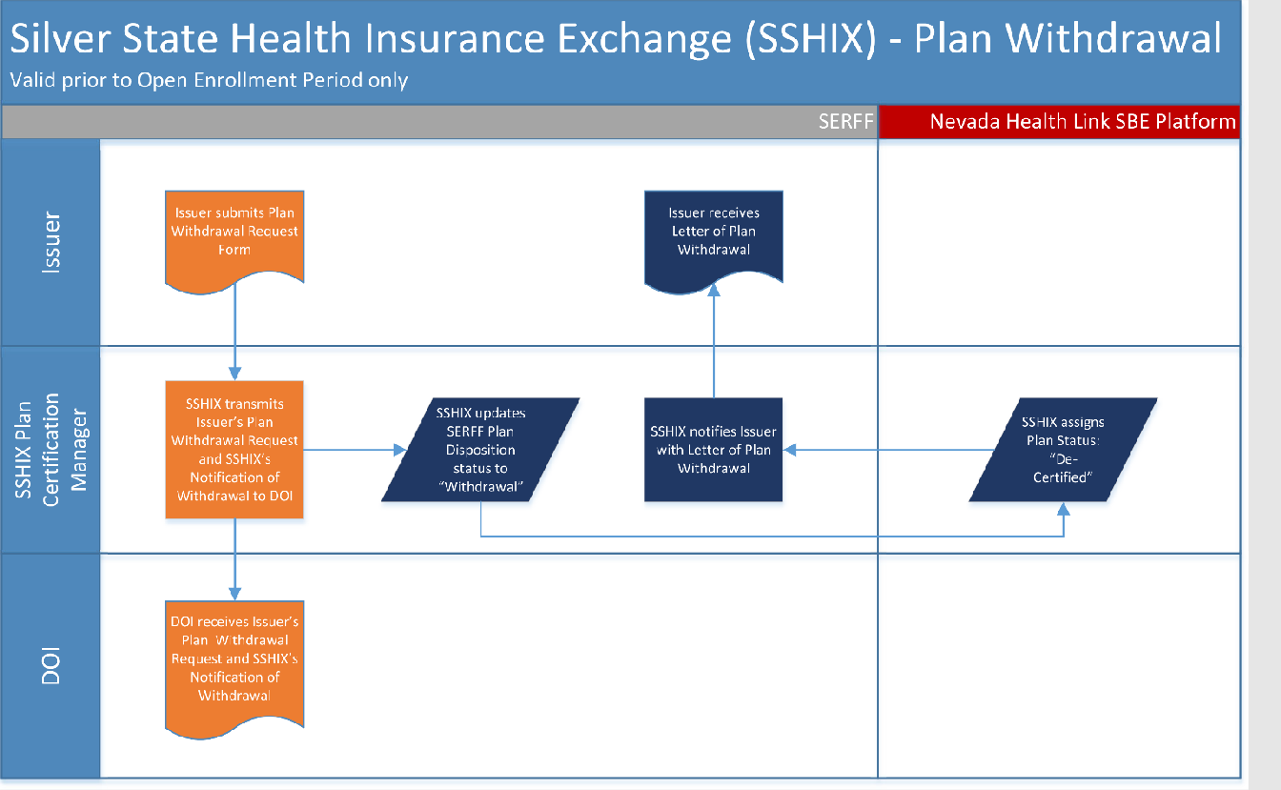
Figure 4 – Plan Withdrawal
Figure 4 illustrates the Plan Withdrawal process, which can be executed at an Issuer’s discretion at any time during the annual Plan Certification timeline, so long as no consumers have yet enrolled in the plan. In practical terms this means that plans must be withdrawn before the annual Passive Renewal batch job (also known as “auto-renewal”), which typically runs during the last two weeks of October, immediately prior to the beginning of the Open Enrollment Period.

Withdrawal Request
The Issuer initiates the Withdrawal Request process by submitting a Plan Withdrawal Request Form to pmanagement@nvha.nv.gov. This form is available for download from Nevada Health Link’s Carrier Resources page.
Upon receipt of the Withdrawal Request, SSHIX drafts a Notification of Withdrawal, which is then transmitted to DOI along with a copy of the Issuer’s Plan Withdrawal Request.

Plan Withdrawal Confirmation
If the plan is eligible for withdrawal then SSHIX updates the SERFF Plan Disposition status to “Withdrawal,” and the status on the SBE Platform is updated “De-Certified” to prevent the plan’s public availability. SSHIX then sends the Issuer a Letter of Plan Withdrawal via email.

Plan Decertification
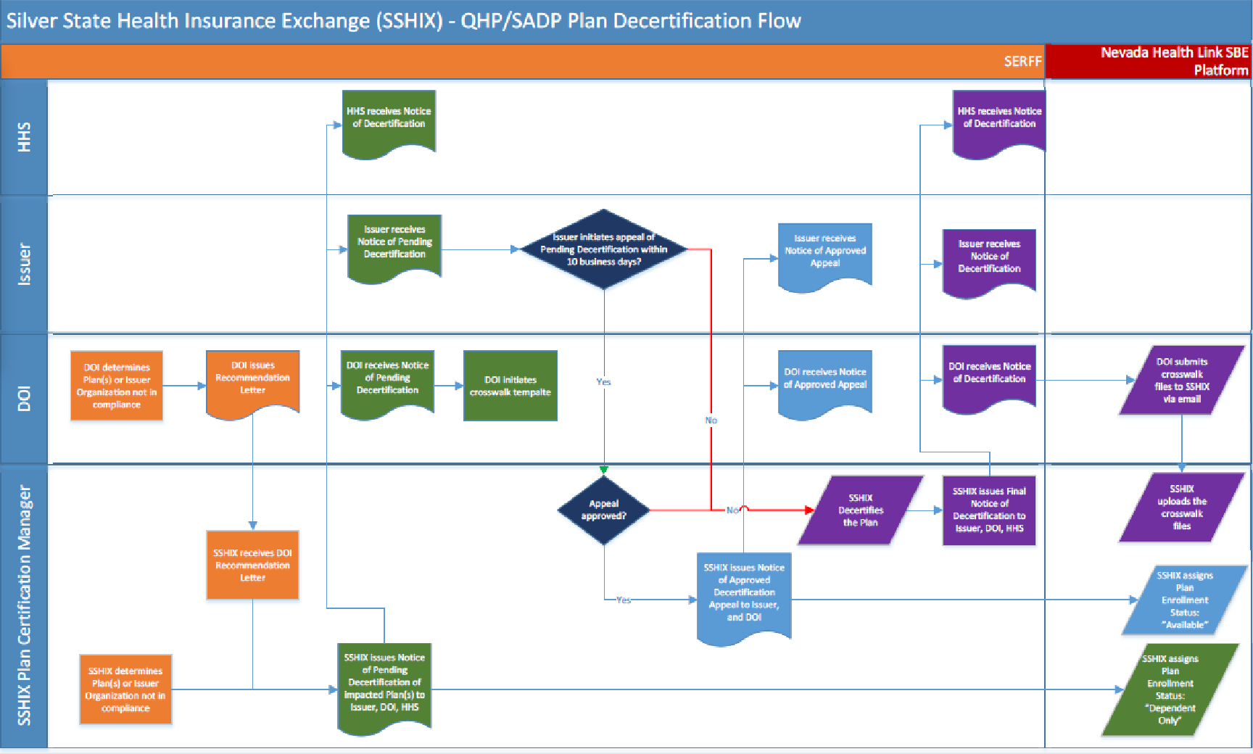
Figure 5 – Plan Decertification

Figure 5 illustrates the Plan Decertification portion after the annual Plan Certification timeline. This process can be executed during the Special Enrollment Period, after the annual Open Enrollment Period. It can also be performed if a Carrier becomes non-compliant during the Open Enrollment Period. The Decertification process strictly adheres to guidance in 45 CFR 155.1080.

Non-Compliance Determination
The Non-Compliance Determination process can be initiated separately either by SSHIX or DOI.
If it is determined that a Carrier has fallen out of compliance, both SSHIX and the DOI will work with the Carrier to bring them in to compliance.
Should DOI determine that the Carrier fell out of compliance based on Network Adequacy issue, or Carrier insolvency issue. In that case DOI will provide SSHIX with a written recommendation letter to take action on the Carrier's standing.
Should SSHIX determine a Carrier fell out of compliance for matters associated with failure to comply with signed Issuer Agreements, though not limited to the collection of payments, and the general certification criteria outlined in 45 CFR 155.1000, SSHIX may take action to decertify the QHP or QDP. In that case, SSHIX will provide DOI a written recommendation letter to take action on the Carrier's standing.
If, following efforts to bring the carrier into compliance, the Manager of Plan Management, in consultation with the Policy and Compliance Manager, determines that a carrier or Plan is unable or unwilling to meet the authorization requirements or certification standards established in State and/or federal law, where those requirements or standards are not otherwise under the regulatory and enforcement authority of SSHIX or DOI, the Manager of Plan Management will prepare a decertification report. The report will detail the issues of noncompliance, any corrective actions taken by the carrier to date and the results of those actions, and any other important information.
In making the determination regarding whether it is appropriate to require corrective action or to deny, revoke, or suspend certification, the Policy and Compliance Manager and the Plan Management Manager will consider:
    - the impact of the carrier or Plan’s noncompliance on enrollees, SSHIX and DOI, the individual market, and the federal government,
    - the impact of the carrier or Plan’s decertification on enrollees, SSHIX and DOI, the individual market, and the federal government,
    - the carrier or Plan’s history of noncompliance and corrective action,
    - whether the noncompliance was accidental or intentional, and
    - any other relevant information

1.1 Notice of Decertification
SSHIX will issue the Notice of Pending Decertification of impacted plan(s) to the issuer, HHS and DOI via email and formal letter. Once the Pending Decertification Notice is received by all parties, DOI will initiate the Plan ID Crosswalk Template for the plan(s) impacted.

Appeals Process
The issuer initiates appeal of Pending Decertification within 10 business days by notifying SSHIX via formal letter. SSHIX will have 30 days to review the appeal, in which the impacted plan(s) will be updated “Dependent Only” on the SBE Platform.
If the appeal is approved, SSHIX will then issue Notice of Approved Decertification Appeal to the issuer and DOI via formal letter and email, and the status for the impacted plan(s) on the SBE Platform is updated “Available.”

Decertification Process
If the appeal is denied, SSHIX will decertify the impacted plan(s) and the status for the plan(s) on the SBE Platform will remain “Dependent Only.” SSHIX will issue Final Notice of Decertification to the issuer, HHS and DOI via a formal letter and email. On receipt of the Notice of Decertification, DOI will submit the Plan ID Crosswalk files to SSHIX via email. SSHIX will upload the Plan ID Crosswalk files for all effected consumers enrolled in the impacted plan(s).

Appendix A: Plan Certification Statuses

Plan Certification Status
The Plan Certification Status relates primarily to the binder review and approval processes described in Sections 2 and 3, but Certification Status is also relevant to the Plan Withdrawal process described in Section 5.

Status | Description
Loaded | When Plan Data is imported from SERFF, each plan is automatically  assigned a default status of “Loaded.”
Certified | Following the binder review process, SSHIX Plan Certification Manager assigns a status of “Certified” to make Plan Data available for review in the Issuer Plan Preview module.
Incomplete | This status is assigned by the SSHIX Plan Certification Manager to accommodate revisions to previously submitted Plan Data. Once a plan is marked as "Certified,” new updates from SERFF are not accepted. The status of the plan needs to be changed to "Incomplete" to allow the SBE Platform to overwrite the previous version of the plan data.
De-Certified | If an Issuer submits a Plan Withdrawal Request, this status is assigned by the SSHIX Plan Certification Manager in order to prevent the plan’s public availability.

Verification Status
The Verification Status relates to the Issuer’s review of plan data using Plan Preview and can only be modified for plans whose Certification Status has been updated to “Certified.”
The default Verification Status is “No.” If an Issuer reviews and approves plan data using Plan Preview, then the Issuer Representative updates the Verification Status to “Verified” (Yes), allowing the SSHIX Plan Certification Manager to make the plan publicly available.

Availability Status
Availability Status determines whether or not a plan is publicly available during Window Shopping, OEP, and SEP.
The default status is “Not Available.” After the Final Plan Certification process (Section 4) the SSHIX Plan Certification Manager will identify all plans whose Verification Status = “Verified” and then update their Availability Status to “Available.” When a plan’s Certification Status is changed to “De-Certified,” its Availability Status is automatically updated to “Not Available” or “Dependents Only”.

Terms and Definitions

TERMS | Definitions
Availability Status | Availability Status determines whether or not a plan is publicly available during Window Shopping, OEP, and SEP.
Certified | Following the binder review process, SSHIX Plan Certification Manager assigns a status of “Certified” to make Plan Data available for review in the Issuer Plan Preview module.
De-Certified | If an Issuer submits a Plan Withdrawal Request, this status is assigned by the SSHIX Plan Certification Manager in order to prevent the plan’s public availability.
DOI | Division of Insurance
Incomplete | This status is assigned by the SSHIX Plan Certification Manager to accommodate revisions to previously submitted Plan Data. Once a plan is marked as "Certified,” new updates from SERFF are not accepted. The status of the plan needs to be changed to "Incomplete" to allow the SBE Platform to overwrite the previous  version of the plan data.
Issuer Representative | Specific user role in the SBE Platform which is associated with the Verification/Plan Preview functions
Issuers | Nevada’s On-Exchange Insurance Carriers
Loaded | When Plan Data is imported from SERFF, each plan is automatically  assigned a default status of “Loaded.”
Plan Certification Process | Applies to the time period between the initial binder submission deadline and the close of Plan Preview
Qualified Dental Plan | A dental Insurance health plan that is qualified for use on the Exchange.
SBE | State Based Exchange
SERFF | System for Electronic Records and form Filings
SSHIX | Nevada Health Authority, Division of Consumer Health Services, Silver State Health Insurance Exchange

Document Revision History

Version | Issue Date | Changes | Drafted | Approved
1.0 | August 2, 2019 | Initial Release | Vinit Yagnik | Russell Cook
2.0 | June 24, 2021 | Textual Updates –  Decertification Update | J. Sawyer | R. High
3.0 | April 18, 2022 | Textual Updates and added  Terms and Definitions | M. Werth Ranson | G. Castaneda
4.0 | March 30, 2023 | Textual Updates –  Decertification Update, Reorganization of document | M. Werth Ranson | G. Castaneda
5.0 | August 21,  2025 | Textual Updates | M. Werth Ranson | J. Krupp
6.0 | February 12, 2026 | Textual Updates and PM NVHA Email Address update | D. Dyer | M. Borgman

